2024

Medical Explorations Application

The Future Docs program is designed for future professionals pursuing a career in healthcare.
This program is sponsored by the Chattanooga-Hamilton County Medical Society the Medical Foundation of Chattanooga to offer college students or recent high school graduates the opportunity to observe physicians and gain an insight in the practice of medicine.
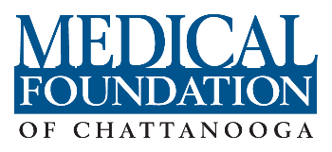
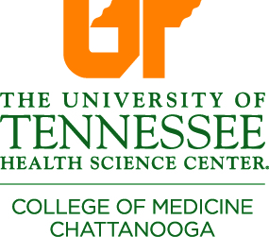

Structured Didactics and Clinical Observations at the Erlanger Health System
with University of Tennessee College of Medicine Chattanooga Faculty
Future Docs Medical Exploration Program
May 12-24, 2024
APPLICATION DEADLINE – APRIL 24, 2024

Student Demographic Information (Please Print)
Full Name:
Full Address:
City: State: Zip:
Home Phone: Cell Phone: Gender:
E-Mail Address:

Student School Information (Please Print)
Name of Current School/University:
City and State of Current School:
Current Ranking (1st - 4th year):
Expected Graduation Year:
Current or Most Recent GPA:

Emergency Contact Information (Please Print)
Emergency Contact Name:
Relationship to Student:
Emergency Contact Phone Number:

References / Recommendations (Please Print)
Please complete the information below for two (2) personal references.
Reference 1 Name: |  |  |  |  | Phone Number:
Email Address: |  |  |  | Job Title:
Reference 2 Name: |  |  |  |  | Phone Number:
Email Address: |  |  | Job Title:
Health / Dietary (Please Print)
If you are selected for this program and we need to be aware of certain health concerns, please list:

If you are selected for this program and we need to be aware of special dietary requirements, please list:

Separate Attachments
Please include the following essays SEPARATELY when submitting your application.
Essay #1 | Please list your extracurricular activities, leadership positions, awards, personal achievements, or recognition  within the last three (3) years.
Essay #2 | What are your expectations for participating in the Medical Explorations Program?
Essay #3 | What competencies and qualities should a physician possess for practice in the 21st century?
Letters of Recommendation |  | Two (2) letters of recommendation from a teacher, university counselor, or supervisor, sent directly to Irene Gruter at irene@chattmd.org
Proof of GPA

Application Agreement
Please check the boxes at the right to indicate your agreement with each statement listed below.
Statement
If selected, I am committed to attend and participate in each of the program sessions.
I acknowledge that full attendance is essential to meet the program’s objectives.
I affirm that the information submitted in this application is true and complete.
I understand that if I am selected into the program, any false statements, omissions, or other misrepresentations made in the application may result in immediate dismissal from the program.

Signature Date

Equal Opportunity Statement: It is the policy of the Medical Society, Erlanger, and the University of Tennessee to provide quality opportunities without regard to race, color, religion, national origin, gender, sexual preference, age, or disability.
- Applicants MUST be at least 18 years of age by May 10, 2024, to be eligible for consideration, NO EXCEPTIONS.
- Please request letters of recommendation to be put onto letterhead stationery and sent directly to Irene Gruter at irene@chattmd.org.
- Please fill out this application and include all separate attachments into ONE email to Irene Gruter at irene@chattmd.org. Only complete applications will be considered.
- Selected applicants will need proof of immunizations, proof of a negative TB skin test within the last 12 months, and proof of COVID vaccinations.

